CPR Broker
PART standard

Magenta Aps
Contents
1 Overall Architecture 3
2 Core PART Engine 4
2.1 Operations 4
2.2 Events 4
2.3 Relations 4
3 Person implementation 5
4 Person data adapters 6

Overall Architecture
The suggested solution is to implement the solution in a generic way. This means that we split the development into multiple phases.
The rationale here is to split the solution into multiple layers that can be built and deployed separately. This way has several advantages
- The work can be kept clean.
- We can make sure that the standard is met; without the complexities of changing a lot of code that is related to persons.
- The core engine can be used later for other implementations if desired.

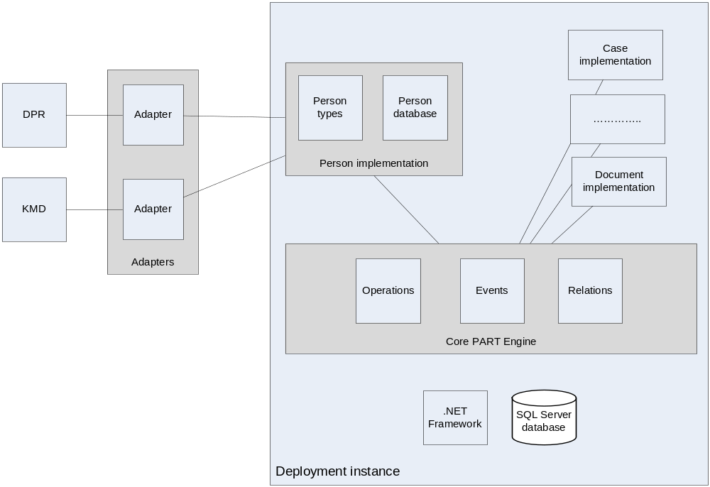

Core PART Engine
We suggest that we first build a generic PART engine that implements the operations as specified in the document “General properties for service interfaces at the case and document area - OIO - Approved.doc”.
The advantage of this part is that the engine can be used for any other type of PARTs. This could be a person, an address, a case, etc. This helps keeping the work consistent and loosely coupled.
This part is mainly a .NET class library that has the base classes with the overall logic for object handling. It also includes the basic database tables used for modeling of objects.
There will be a group of virtual methods that partly pass control to child classes (like those for person implementation) to do implementation specific logic (like saving a person to a database).
It will have a separate installer that creates a small website and a little database.

Operations
This part will implement the standard operations as described in the specification. The implementation should handle the specified operations, taking care of issues like synchronization, uniqueness and so on.

Events
This part will contain a generic implementation of object notification on updates. It will be implemented as a publisher/subscriber model.

Relations
Will contains a generic mechanism for handling of relations between objects. Things like deletions of referenced objects and so on.

Person implementation
This part will be built on top of the core engine. Installation of this part will allow the target system to ‘digest’ person objects. This can be generalized to any other object type.
This part will be a .net library that uses the core classes, and overrides certain methods to provide business logic that is specific to dealing with Person objects.

Person data adapters
This part will contain the link between the new system and the existing KMD and DPR systems found in the municipalities. It will copy some implementation details from CPR Broker.
This component will typically be some module that provides a PART interface for KMD & DPR. Usually this interface will only allow read operations, so the other part to build is some application that takes data from DPR & KMD and saves it to a system with a Person implementation.

